# ­­­­my clinic

# Smart Appointment Booking – CRM Project

## Phase 2: Org Setup & Configuration

* Goal: Prepare Salesforce environment.

### 1. Salesforce Editions

Used Salesforce Developer Edition Org for implementation.

**Developer org used**: madurudurga360@agentforce.com

### 2. Company Profile Setup

Configured clinic information, local time zone, and INR currency for reporting.

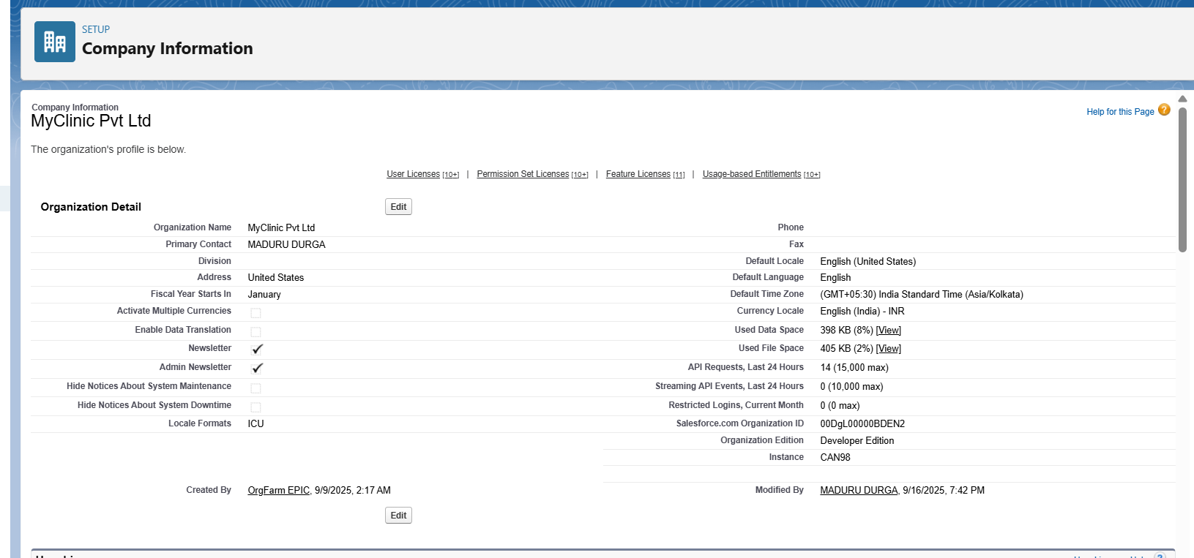

### 3. Business Hours & Holidays

* Set hospital working hours (9 AM – 5 PM).
* Added weekends and public holidays to restrict booking.

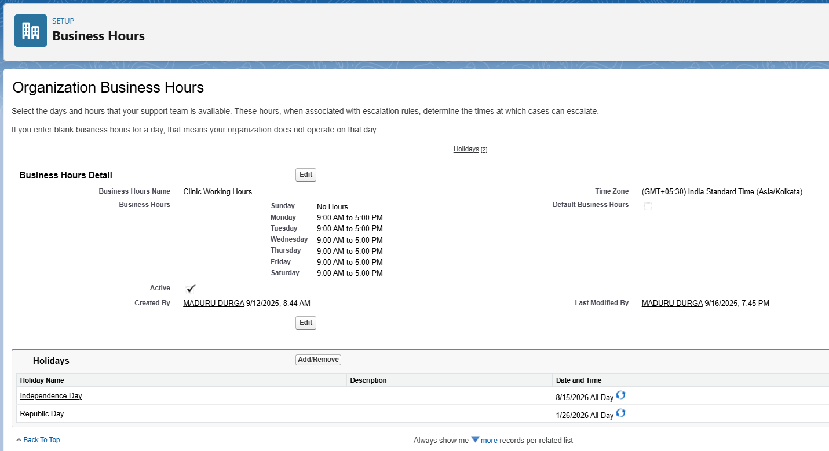

### 4. Fiscal Year Settings

* Enabled Standard Fiscal Year (Jan–Dec) for reporting.

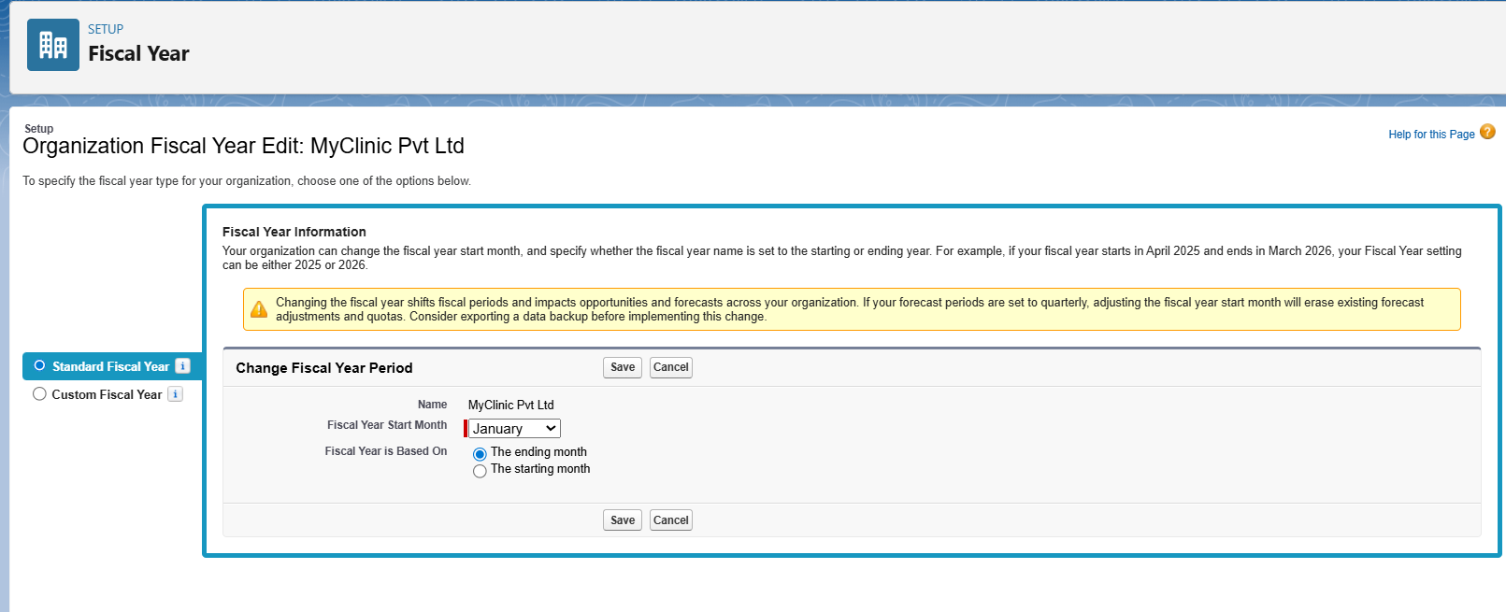

### 5. User Setup & Licenses

Created users: Admin/Manager, Doctors, Patients (Community/Portal).

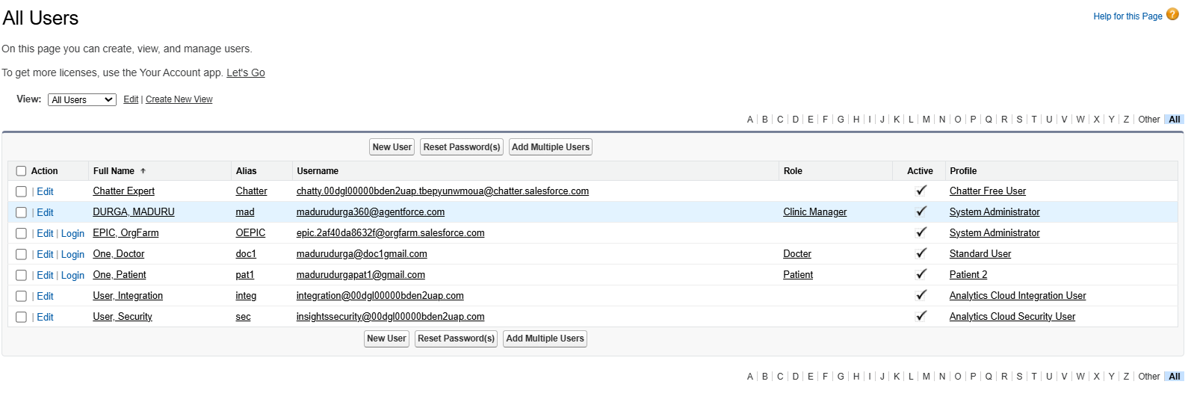

### 6. Profiles

* Admin(me) – Full access.
* Doctors – Manage appointments.

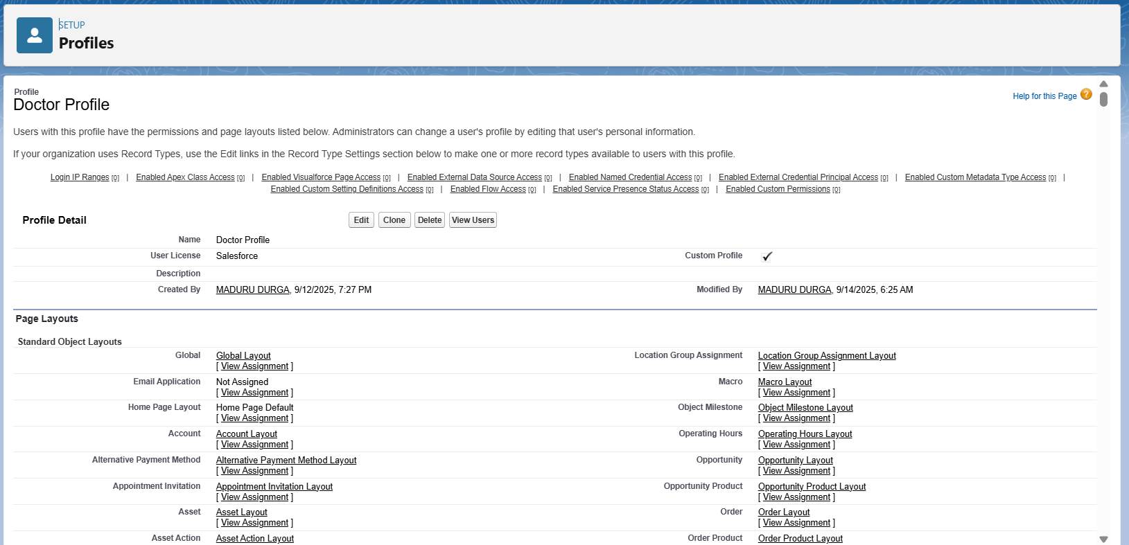

* Patients – Limited access for booking.

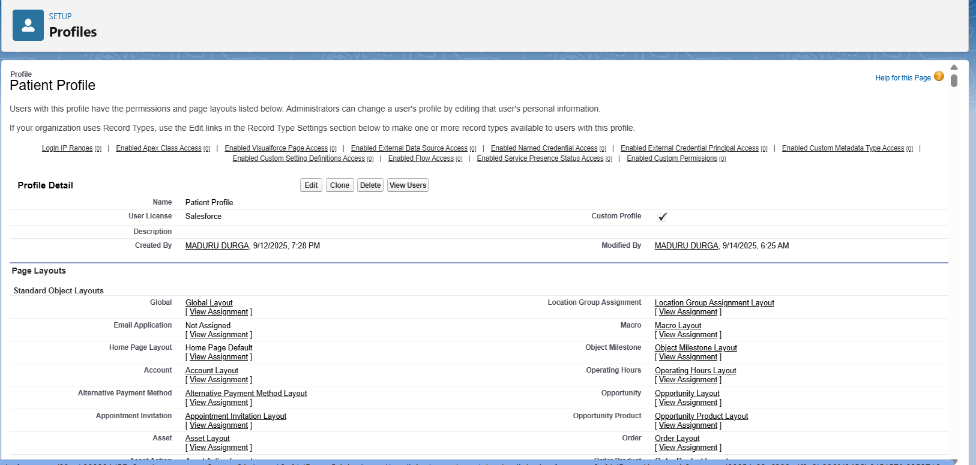

### 7. Roles

Hierarchy: Admin/Clinic Manager → Doctors → Patients.

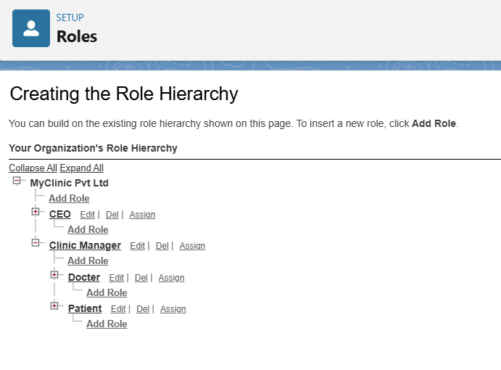

### 8. Permission Sets

* Created additional permission sets for doctors to access reports/dashboards.

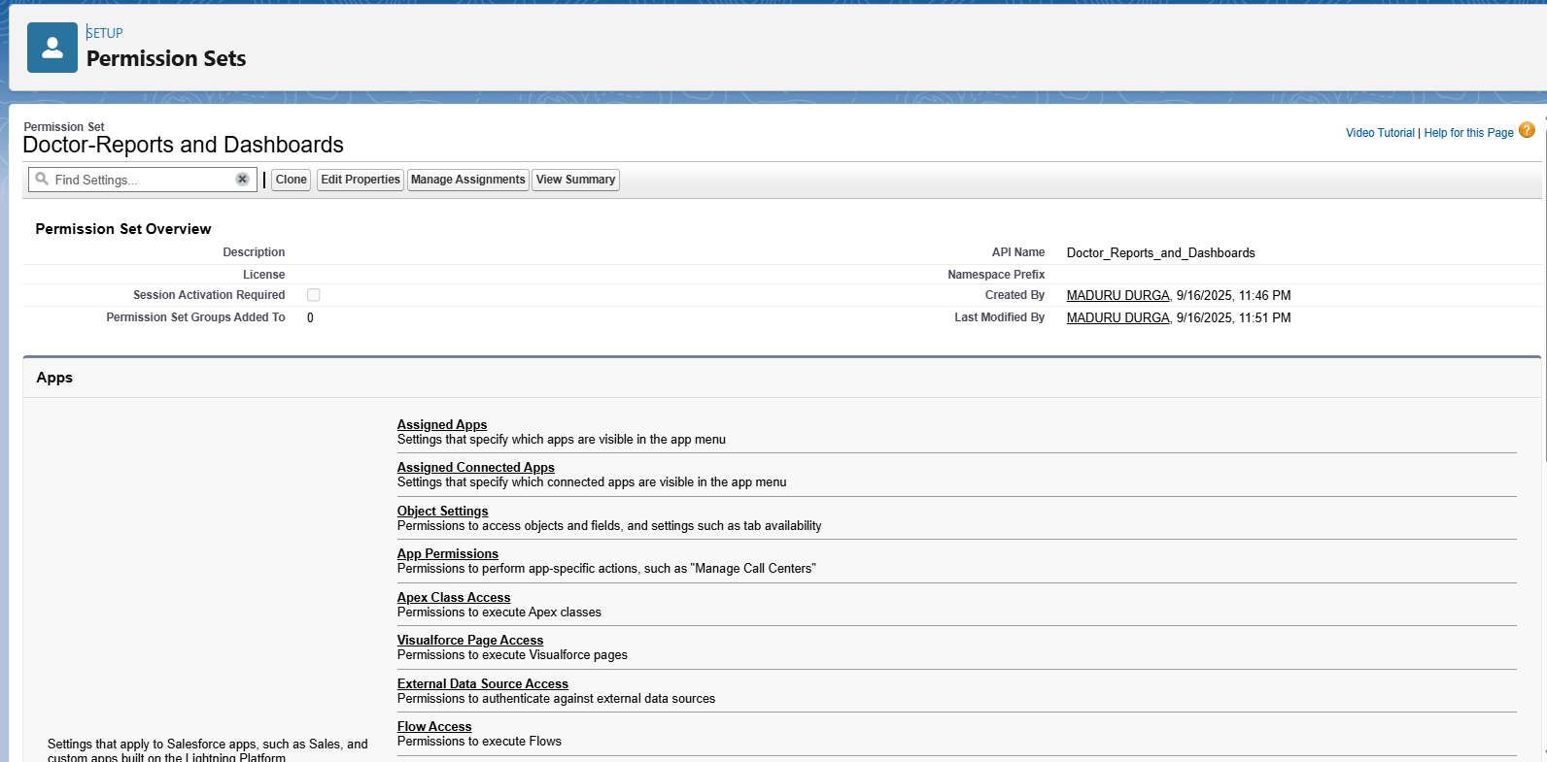

* Created Appointment booking accesses to patient using patient-Appointment Access permission set.

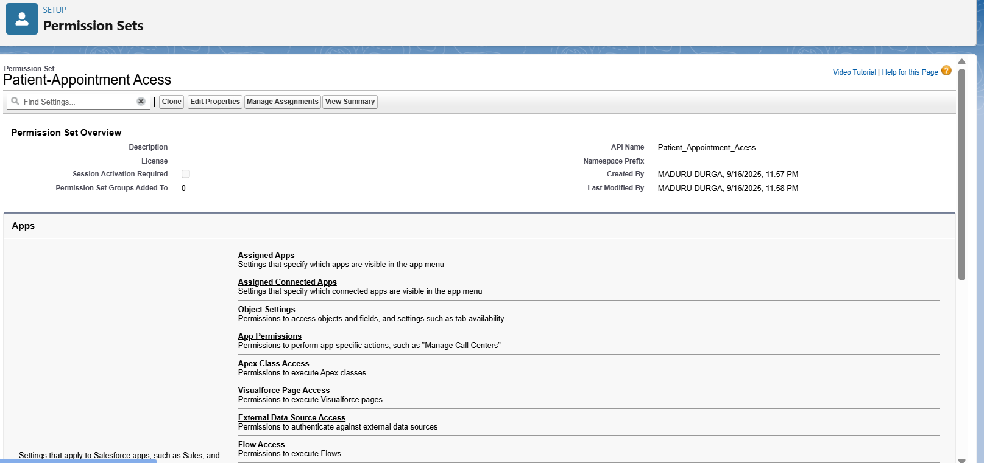

### 9. OWD (Org-Wide Defaults)

* Appointments – Private.
* Doctors – Public Read Only.
* Patients – Private.

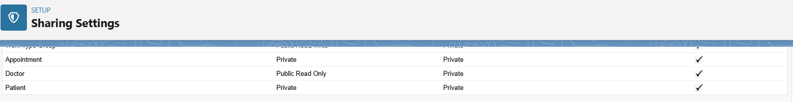

### 10. Sharing Rules

* Appointments shared with Admin role automatically.

### 11. Login Access Policies

* Doctors restricted to login 9 AM – 5 PM.
* Admin – full access.
* Patients – 24x7 access.

### 12. Dev Org Setup

* Developer Org used as sandbox for building and testing.

### 13. Sandbox Usage

* Documented process for Sandbox → Production deployment in real-world usage.

### 14. Deployment Basics

* Prepared Change Sets for moving configurations. Documented SFDX/VS Code deployment methods.